Digital Wellbeing Research

As a Data Analyst collaborating with Dr. Elena Vance, a renowned clinical psychologist and behavioural researcher. I am co-authoring our upcoming book examining the modern attention crisis: Hooked on the Feed: Rewiring the Distracted Brain.

Between clinical patient hours, guest lectures, and book drafts, Dr. Vance does not have the bandwidth to run the raw statistical breakdowns herself. She has commissioned this data investigation using empirical participant tracking data (N = 300) to substantiate four cornerstone chapters in our book.

My role is to uncover, model, and translate the data into clear behavioural insights that form the empirical backbone of our manuscript.

The 4 Core Hypotheses to Investigate:
- How does daily social media consumption impact cognitive focus, deep work, and task completion?
- Does the primary social media platform used correlate with differences in productivity and attention?
- What role does sleep duration play in relation to social media use and productivity?
- How does digital distraction vary across occupation categories or education levels?
Analysis

- How does daily social media consumption impact cognitive focus, deep work, and task completion?

Objective: To evaluate the empirical relationship between escalating daily social media usage and key markers of cognitive performance, specifically examining whether prolonged daily consumption degrades sustained attention spans, deep work endurance, daily task throughput, and self-perceived productivity

Methodology & Definition:
- Groups: We divided all 300 participants into three groups based on their daily social media hours:
- Low: Less than 3 hours per day
- Moderate: 3 to 6 hours per day
- High: More than 6 hours per day
- Measurements: For each group, we calculated the average for productivity score (out of 10), attention span (in minutes), deep work time (in minutes), and tasks completed per day.

Findings:
- Deep work drops heavily: Deep work time drops from 114.55 minutes in the low group to just 18.67 minutes in the high group (an 83.7% drop).
- Attention span gets much shorter: Low users can focus for an average of 47.46 minutes, while high users can only focus for 8.65 minutes (an 81.8% drop).
- Fewer tasks get done: People in the low group finish about 8.29 tasks each day, but high users only finish 2.92 tasks (a 64.8% drop).
- Productivity feels much lower: The average self-rating for productivity drops from 9.05 out of 10 (low) to 5.65 (moderate), and hits 3.27 for high users (a 63.9% drop).

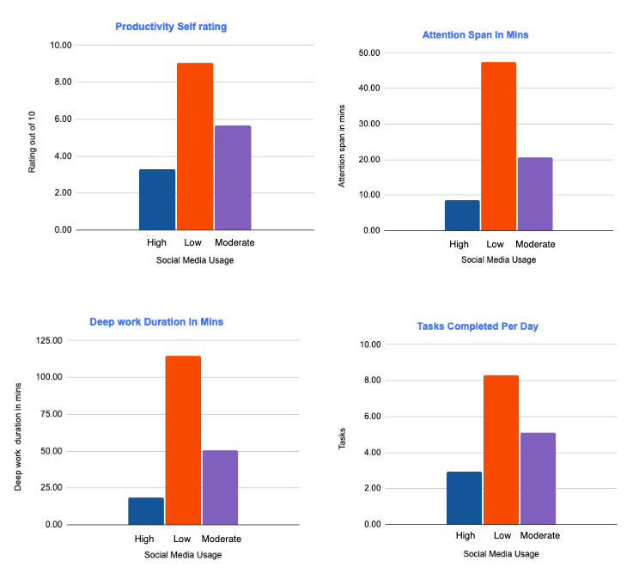

- Does the primary social media platform used correlate with differences in productivity and attention?

Objective: To see whether different social media platforms are linked to different levels of daily screen use, attention span, and overall productivity.

Methodology & Definition:
- Platform Breakdown: All 300 participants were grouped by their primary_platform.
- Measurements: For each platform group, we calculated the total user count (COUNTA) and the average for daily social media hours, attention span (minutes), and productivity rating (out of 10).
Findings:
- Short-form video has the lowest scores: TikTok users spend the most time on social media (6.76 hours/day) and report both the lowest attention spans (10.00 minutes) and the lowest productivity rating (3.62 / 10).
- Visual feed apps sit in the middle: Users primarily on Instagram (95 users) and YouTube (50 users) average around 4.9 hours/day of use, with mid-level attention spans (19.19 to 21.16 minutes) and moderate productivity ratings (5.22 to 5.58 / 10).
- Professional and text platforms score highest: Users on LinkedIn and Facebook spend far fewer hours on social media (2.13 and 2.63 hours/day). They report the highest focus (38.98 to 41.27 minute attention spans) and the highest productivity ratings (7.90 to 8.62 / 10).

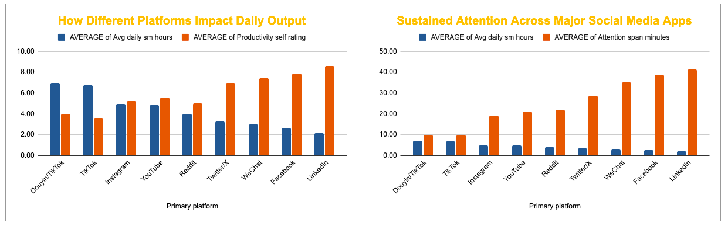

- What role does sleep duration play in relation to social media use and productivity?

Objective: To see how getting enough sleep relates to daily screen habits, sustained focus, and overall productivity.

Methodology & Definition:
- Sleep Tiers: All 300 participants were grouped based on their reported sleep hours (Avg sleep hours):
- Short: Less than 6 hours per night (33 participants)
- Moderate: 6 to 7.5 hours per night (147 participants)
- Optimal: More than 7.5 hours per night (120 participants)
- Measurements: For each tier, we calculated participant counts (COUNTA) and average values for daily social media hours, total screen time hours, productivity rating (out of 10), and attention span (minutes).

Findings:
- Short sleep co-occurs with heavy screen use: Participants getting short sleep spend 7.68 hours/day on social media and 11.71 hours/day in total screen time (over double the screen exposure of optimal sleepers).
- Severe focus deficit in sleep-deprived users: Short sleepers have an average attention span of just 7.55 minutes, compared to 44.06 minutes for those getting optimal sleep (an 82.9% focus drop).
- Productivity takes a heavy hit: Self-rated productivity drops from 8.69 out of 10 in the optimal sleep group down to 2.91 out of 10 for short sleepers (a 66.5% decline).
- The biological buffer: Optimal sleep (>7.5 hours) acts as a strong cognitive anchor, coinciding with much lower daily digital consumption (2.04 hours of social media and 5.61 hours of total screen time).

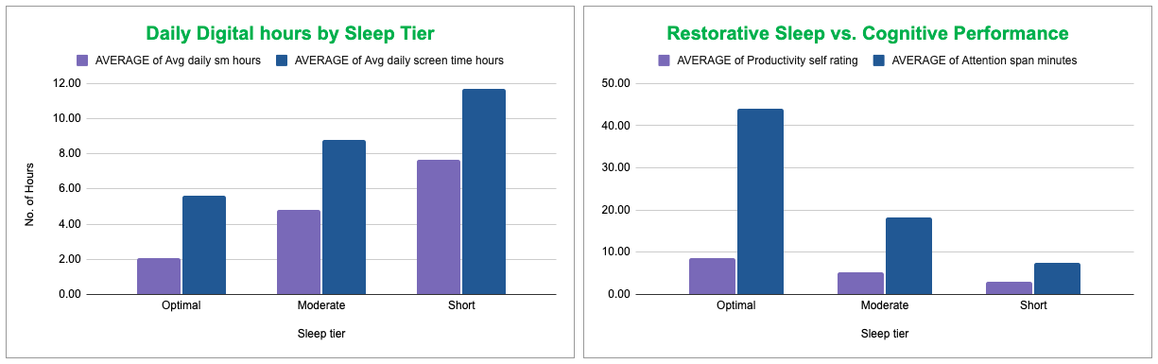

- How does digital distraction vary across employment type and education levels?

Objective: To see how different life stages and daily routines, like being a student, working full-time, or being retired, relate to social media use, self-rated productivity, and daily task completion.

Methodology & Definition:
- Grouping: Participants were grouped by both their Employment status and Education level to see how routine demands shape habits.
- Measurements: For each segment, we calculated participant counts (COUNTA) and the average for daily social media hours, self-rated productivity (1–10 scale), and completed tasks per day.

Findings:
- High school students log the highest phone usage: High school students spend an average of 7.05 hours/day on social media, reporting very low productivity (3.44 / 10) and completing only 2.90 tasks/day. Undergraduate students follow closely at 6.24 hours/day of social media and 3.64 tasks/day.
- Retired individuals have the lowest usage and highest scores: Retired participants spend the least time on social media (1.16 to 1.20 hours/day). They report nearly perfect productivity scores (9.55 to 9.60 / 10) and complete the most tasks daily (9.32 to 9.60 tasks/day).
- Full-time workers show structured moderation: Full-time employed participants (who make up the largest share of the study with 188 individuals) average between 2.96 and 3.75 hours/day of social media. Their productivity remains solid at 6.51 to 7.52 / 10, with 5.88 to 6.76 tasks completed daily.
- Clear inverse pattern: Across every single demographic group, higher daily screen time consistently mirrors lower perceived productivity and lower task completion.

